Project Report on

Musical Instrument Shop Management System

Submitted to

Savitribai Phule Pune University

In the partial fulfillment of the requirement of the award of the degree of

Bachelor of Business Administration- Computer Application,

TYBBA -CA, Sem V

Academic Year 2019-20

By

Pranalee Mansing Solaskar

Under the guidance of

Prof. Vidya Chandgude

Through



Alandi (D)- Pune 412105

**Alandi (D) - Pune 412105**

CERTIFICATE

Department of Computer Application

This is to certify that Ms. **Pranalee Solaskar**, of TYBBA-CA, Sem V, Exam Seat No. , has successfully completed project work entitled **Musical Instrument Shop Management System** in the partial fulfillment of the requirement of the degree of Bachelor Of Business Administrator-Computer Application for the Academic Year 2019-20

Prof. Vidya Chandgude Prof. Akshada Kulkarni

Project Guide Head of the Department

Internal Examiner I External Examiner

**Acknowledgement**

The words are not enough to express my thanks to **Dr. B. B. Waphare**, **Principal, MIT Arts Commerce and Science College Alandi (D)** for providing me with the opportunity to avail the excellent facilities and infrastructure of the institute.

It is my proud privilege to express my profound gratitude to **Prof. Akshada Kulkarni, HOD, Computer Application Department**, for her astute guidance, constant encouragement and sincere support throughout my academic course.

I thanks to my honest gratitude to **Prof. Vidya Chandgude** for her inspiration, constructive suggestions and affectionate guidance in my project work completion.

Last but not the least, I express my sincere thanks to all my dear friends and family members for their constant motivation, moral support and invariable direction throughout my life.

DECLARATION

I, **Pranalee Mansing Solaskar,** hereby declare that this project work entitled **Musical Instrument Shop Management System** submitted at MIT Arts, Commerce and Science College, Alandi(D), (Affiliated to Savitribai Phule Pune University) is a record of original work done by me under the supervision and guidance of Dr. Vikas Mahandule, Department of Computer Application.

Signature:

Name of Student: Pranalee Mansing Solaskar

Exam Seat No.:

Place : Alandi (D), Pune

Date :

**Index**

|  |  |  |
| --- | --- | --- |
| **Sr. No** | **Title** | **Page No** |
| **1** | Introduction  Introduction to system  Scope of the system  Proposed System | **6-7** |
| **2** | Analysis  Fact Finding Technique  Feasibility Study  Hardware & Software Requirement | **8-9** |
| **3** | System Design  E-R Diagram  Data Flow Diagram  Data Dictionary | **10-14** |
| **4** | Form Design (with input values) | **15-29** |
| **5** | Reports | **30-31** |
| **6** | Advantages & Limitations | **32** |
| **7** | Future Enhancement | **33** |
| **8** | Bibliography | **34** |

# Introduction

# INTRODUCTION To System

The project titled as “Musical Instruments Shop Management System “ is a software application developed using vb 6.0 and access database . In the end of month or year there report generation done

This software made for keep record. Shopkeeper can handles record about customer ,suppliers and instruments.According to which they give service to customer .The main purpose of developing this system to reduce existing manual system by the help of computerized equipments and software for fulfilling the company’s requirements like .If they want stock details ,product details ,order details etc

.

If admin can requires any instrument information. It can easily get information.In manual system there will be lack of information . In this system there will not be lack of Information. Manual Data entry in books is very time consuming and difficult to understand and keep track of as compared to that of the new computerized system. There is wastage of time, money and paper in the current system. To overcome all such difficulties, technical managerial and physical. The new computerized system comes into play.

This system helps to understand payment information about suppliers

and customer .According to which further communication can be easily done.in manual system there was hard to understand payment information bez of that lack of payment happned

Scope

The project is basically meant to computerized the existing system for order and training sessions so as to gain accuracy,processing speed,data so as to gainAccuracy,processing speed ,data consistency ,identify better error handling .

The proposed system mainly covers the following

* Login form
* Instrument form
* View orders
* Customer details
* Customer Payment details
* Employee details
* Supplier details
* Supplier order form
* Repairing form
* Stock details

# PROPOSED SYSTEM:

* Musical Instruments Shop management system is used to maintain all instrument and their company with updated details
* Objective of the system is to maintain all sales details with complaint and services
* One of the main objective is to to give product satisfaction to all the customers by fulfilling their requirements and needs
* In the system we are maintaining all the details of the customer with their feedback
* We are also maintaining all the details of the available stock
* We are also maintaining employ details

**ANALYSIS**

**Fact Finding Techniques**

The following fact finding techniques were utilized for gathering the information about the problem definition and requirements:-

* **Questionnaires**

Questionnaires were given to Musical Instrument Shop as well to find out what are the most important requirements from the system. The questionnaires comprised of mostly MCQs to help condense the data into groups.

* **Interviews**

A few one on one interviews were conducted to get information about what difficulties do the Musical Instrument Shop rectors face in their day to day tasks.

* **Record Review**

There are a lot of records available online and they give access to a very large amount of information. That information is taken as the larger perception of the audience.

**Feasibility Study**

* **Technical Feasibility**

The firm has to purchase a Pentium machine or higher version the computer must be running window XP or greater having the software necessary to run the system i.e. V.B. 6.0 and M.S. Access. As the hardware and software needed for designing and implementation of the system is already is technical feasibility.

* **Operational Feasibility**

Themain users of the system would be the person doing the present clerical job. A description of the method to operate the system would be enough having a graphical user interface the system will be user friendly. Also, they won’t find it difficult to migrate to new system.

* **Economic Feasibility**

This is concern with cost include for development and implement of the system and the benefits derived from it. The hardware and software requirement for the system is already available. The only cost involved is that of coding implementation and maintaining the system.

Software Requirements:

* Windows Operating System(7 or above)
* Visual Basics 6.0(with working Database connectivity)
* Ms Access(With (.mdb) Compatibility)

Hardware Requirements:

* Processor: 1.2 GHz or Higher.
* **RAM**: 512Mb or More.
* **Storage:** Minimum 5GB free on Disk.

**SYSTEM DESIGN**

3.1 ENTITY RELATIONSHIP DIAGRAM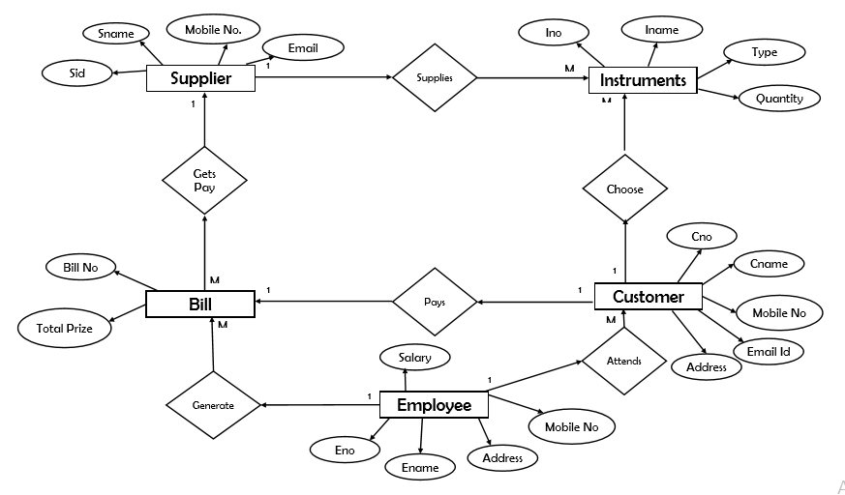

**3.2CLD**

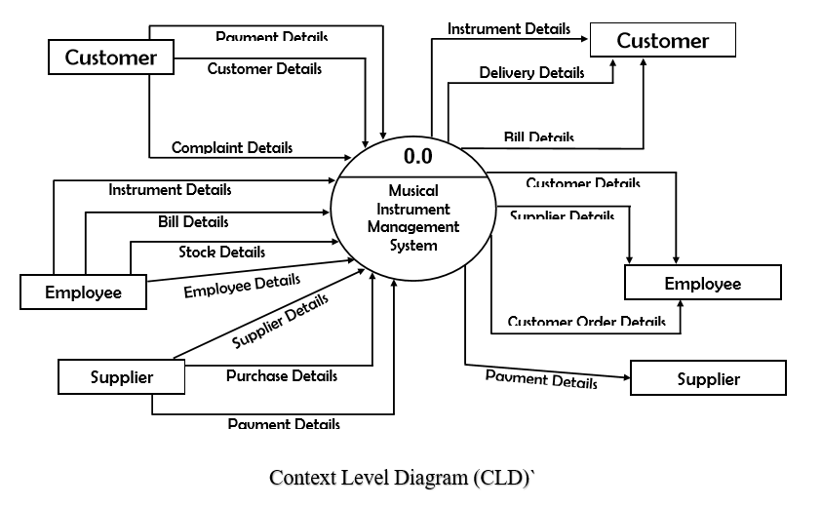**DFD**



## Data Dictionary

**Supplier Table**

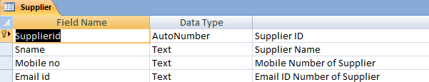

**Supplier Order Table**

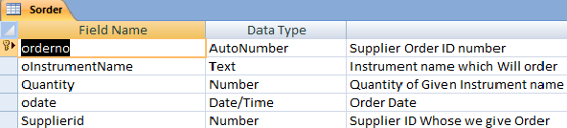

**Employee Table**

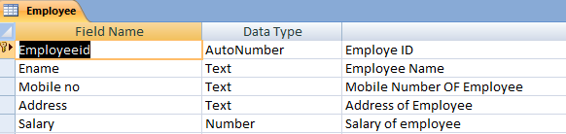

**Instrument Table**

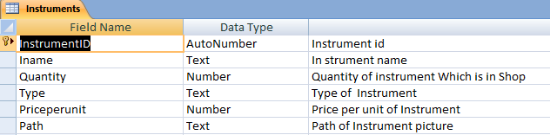

**Customer Table**

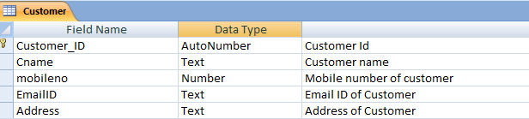

**Customer Order Table**

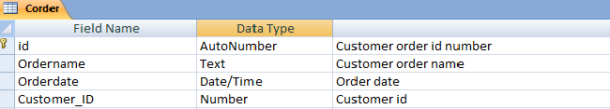

**Customer Buy Instrument Table**

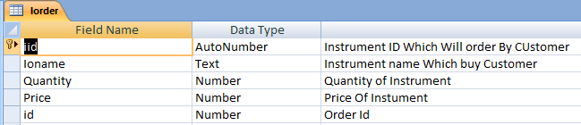

**Form Design**

**ADVANTAGES AND LIMITATIONS**

ADVANTAGES:

* The proposed system for “**Musical Instument shop management System**” is computerized. Today is the era of computers. This software project solves all the problems discussed above in the present system. The main objective of developing this project is to save time and money.
* In the Proposed **Musical Instument shop management System**, the limitations of the legacy system will be overcome.
* The Problems such as data entry will be simpler, faster. The data redundancy problem will be solved and the data will be stored securely.
* A common data base for all of the departments will be used hence there will be centralization of data.
* All departments will have access to real time data updation /deletion/addition. The admin panel will get access to all records of a particular student or particular records of all students on the same unit (computer system).
* The proposed system involves creation of an .EXE file in a single computer where the software installation will take place.
* Data base will be stored on that computer in the hard-drive. Access to the software or the database could be done through that system only.

LIMITATIONS:

* Since with Visual Basics 6.0 the Internet Functionality is limited
* Hence the system is currently a One System Software as the database is not centralized throughout systems. But only on one System.

**FUTURE ENHANCEMENT**

* With the current proposed system and the provided technology. The software becomes non portable. Future scope of the project involves and update where the database is made into a server sided database and the front end application be made into an Application.
* With the use of internet technologies one would be able to access the database to add/delete/update records from any remote location.

**BIBILOGRAPHY:**

During the development of the above mentioned project the following reference links, Books were used.

* Black book of visual basic 6.0.
* Software Engineering Notes [ Semester 3]
* DBMS Notes [For ERD Purposes]
* Websites used:
* [www.vbforums.com](http://www.vbforums.com)
* [www.docs.microsoft.com](http://www.docs.microsoft.com) [vb6.0 help]
* [www.youtube.com](http://www.youtube.com)